Lab: Basic Syntax, Conditional Statements and Loops
Problems for in-class lab for the Python Fundamentals Course @SoftUni.
Submit your solutions in the SoftUni judge system at https://judge.softuni.bg/Contests/1718.

Largest of Three Numbers
Write a program that receives three whole numbers and print the largest one.

Example
Input | Output
3  -1  5 | 5
0  -1  -2 | 0

Hints
We start by reading the three numbers from the console:
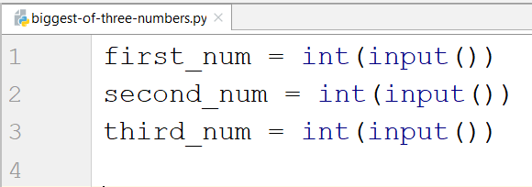
Then we compare them and print the largest one:
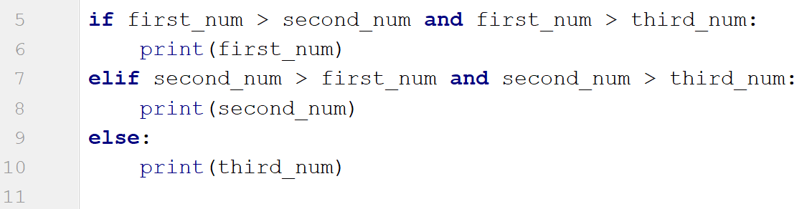

Number Definer
Write a program that reads a floating-point number and prints "zero" if the number is zero. Otherwise, it should print "positive" or "negative". The program should add "small" if the absolute value of the number is less than 1, or "large" if it exceeds 1 000 000.

Example
Input | Output
25 | positive
0.7 | small positive
435247392.921 | large positive
-0.005 | small negative
-103.21 | negative
-358583355123.001 | large negative

Hints
First, we read the number from the console as a float, because we are going to receive floating point numbers:
Then, we write a condition to check if the number is zero:
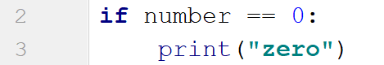
After that, we write a condition to check if the number is positive and add the additional conditions:
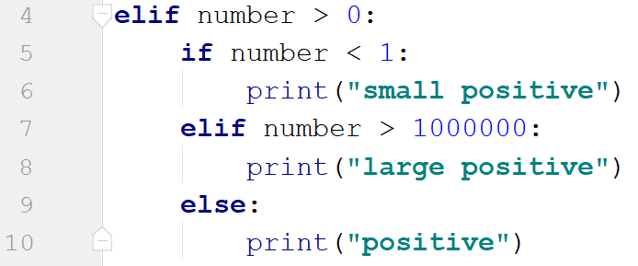
Then, we check if the number is negative. To check if the number is small or large, we use the absolute value of the negative number:
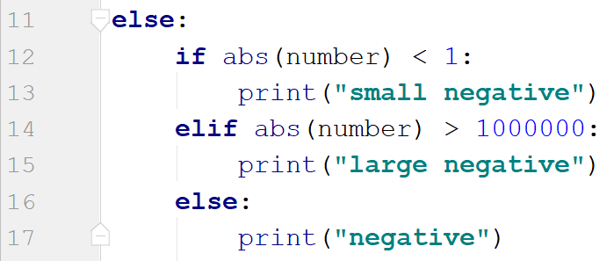

Word Reverse
Write a program that receives a single word from a user, reverses it and prints it.

Example
Input | Output
Python | nohtyP
banana | ananab

Hints
We read the word from the console:
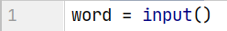
Next, we create new variable to store the reversed word:
After that, we create a for loop which would iterate backwards through the word and add each character to the new word:
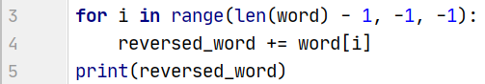
- The starting point value of the loop should be the length of the word minus one position.
- We should loop until we reach the 0 index, so the stop value of the loop should be -1.
- Finally, the step is backwards, so the step size is -1.

Number Between 1 and 100
Write a program which reads different floating-point numbers from the console. When it receives a number between 1 and 100 inclusive, the program should stop reading and should print "The number {number} is between 1 and 100".

Example
Input | Output
-3  0.9  44 | The number 44.0 is between 1 and 100

Hints
We start by reading a floating-point number:
Then, we create a while loop with a condition which checks if the given number is less than 1 or it is greater than 100. If the condition is met, the program should enter the body of the loop:
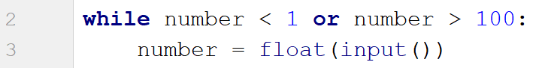
If the condition is not met, we exit the loop and print the result:

Patterns
Write a program which receives a number and creates the following pattern. The number represents the largest count of stars on one row.
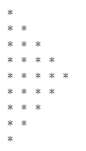

Example
Input | Output
3 | *  **  ***  **  *
5 | *  **  ***  ****  *****  ****  ***  **  *

Hints
First, we read the number from the console:
We create the first loop, which will print the half of the pattern, until i == number:
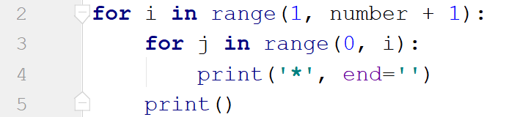
We create the inner loop to loop through the numbers from 0 to i (i is not inclusive). We use end='' to stay on the same line. We print the new line after we draw all the stars for the particular line.
Next, we create the second loop which loop backwards as we need to decrease the number of stars with each line. It should draw one line less than the previous one:
